**CS2022 PROJECT 1- DATAPATH DESIGN**

**PART A**

Aniket Agarwal

17317437

**Contents:**

1. Results Of Test Benches
2. VHDL Component Source Code (With Schematics)
3. Component Test Benches

**1. Results of Test Benches**

a) Project 1B Top Level

The results from this test-bench show that all the modules instantiated together with values are being loaded into the subsequent registers, and micro-operations are then being carried out appropriately with loading into a new register.

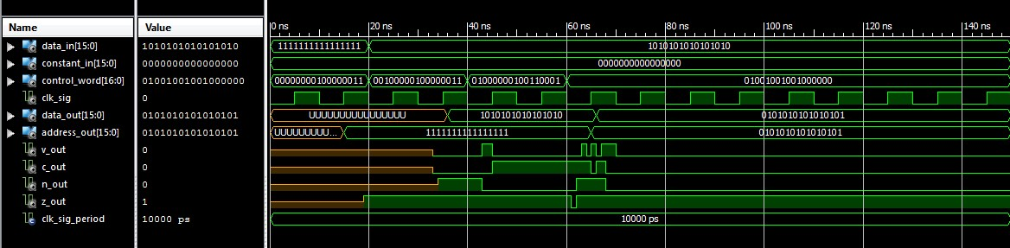

b) Register File

The register file test bench shows the register submodules working together through decoding, multiplexing, storing values and passing data in and out appropriately with respect to the clock period and the load.

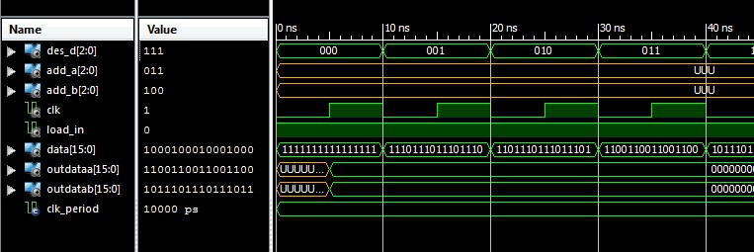



c) ALU Unit

The ALU component functions as intended by having correct outputs on its G pin where it’s a-in, b-in and g-select have data and operations supplied to them. The result is appropriate V and C flags being set, with a 16 bit output on G being output.

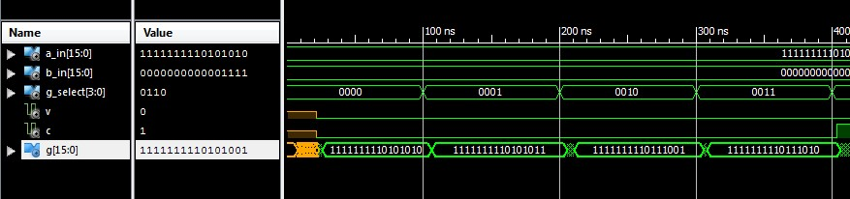

d) Decoder 3-8 bit

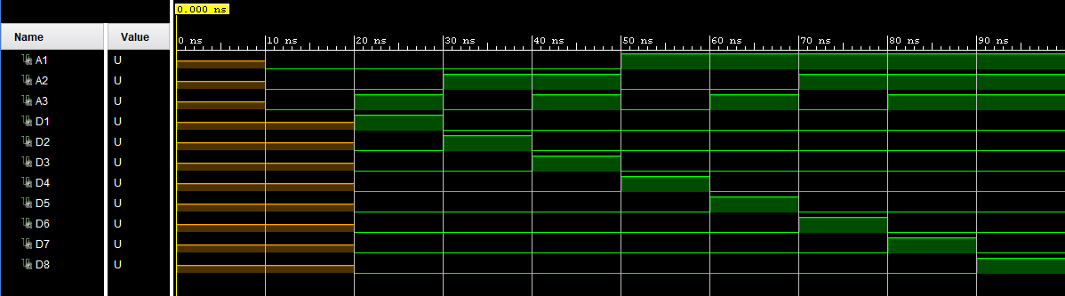

e) Full Adder

For each input, the appropriate carry is determined and correct operations are performed for the given select pin, which results in the intended output.

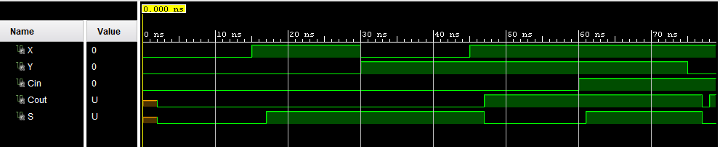

f) Mux 2-1 Bit

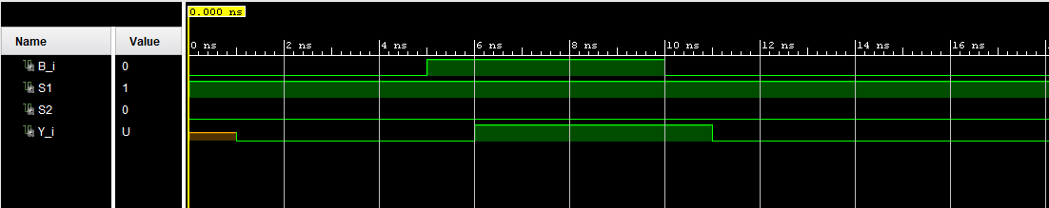

g) Mux 2-16 bit

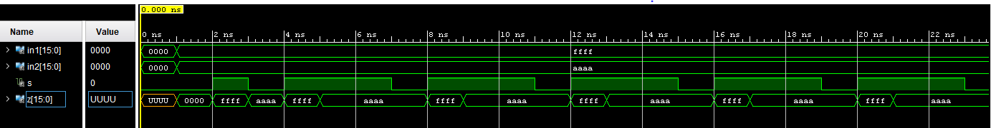

h) Logic Circuit A-B

It provides inputs of A and B logic as well as a select pin that determines the operations to be performed resulting in outputs via gate logic.

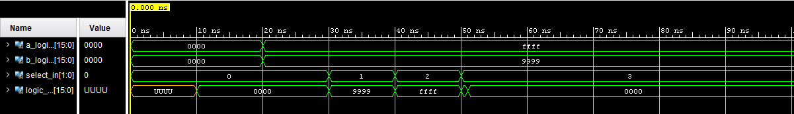

i) Logic Circuit B

The B logic input results in correct outputs for each B and s value provided to the logic circuit.

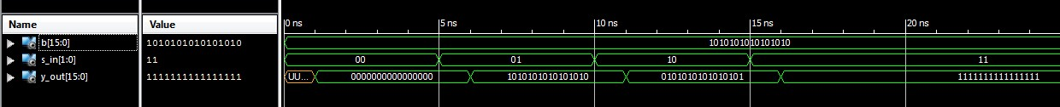

j) Mux 3-1 bit

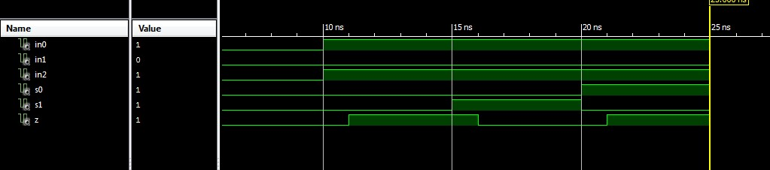

k) Mux 8-16 bit

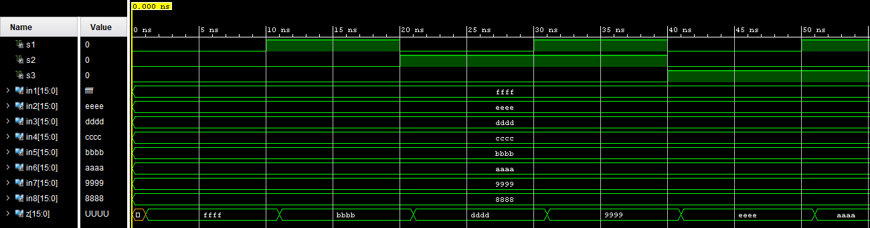

l) Ripple Adder

It appropriately determines the c-in, c-out, and v-out flags with oscillations on its G-out output to between 0 and 1, where the adder itself has two 16 bit inputs a and b.

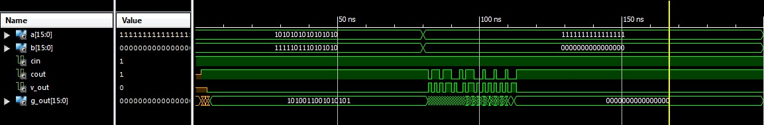

m) Shifter

This component works as intended by outputting correct left and right shifts on the H value, where the data and operations are input on b and s pins.

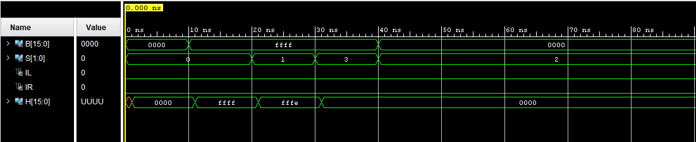

n) Register

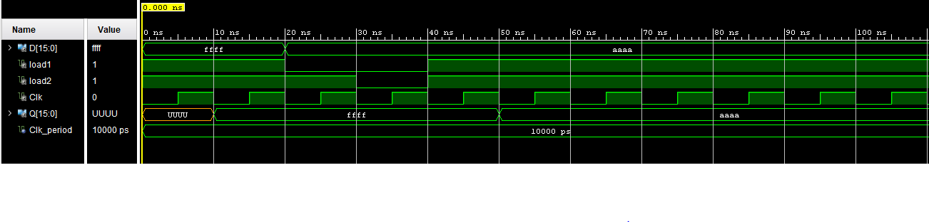

o) Functional Unit

The function unit works as it should be with appropriate values being handled and raising correct N, Z, C and V fags in the unit itself to the word passed in for function selection.

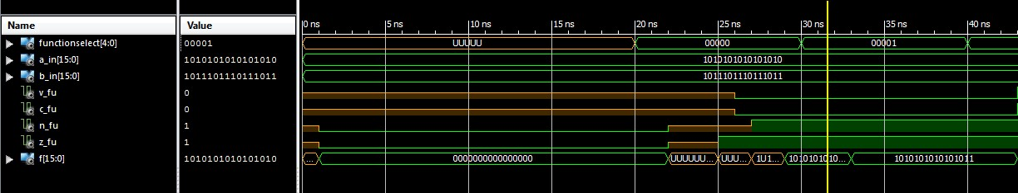

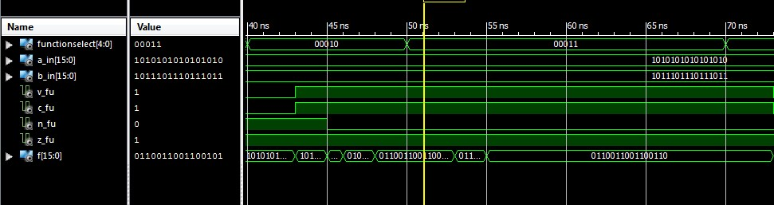

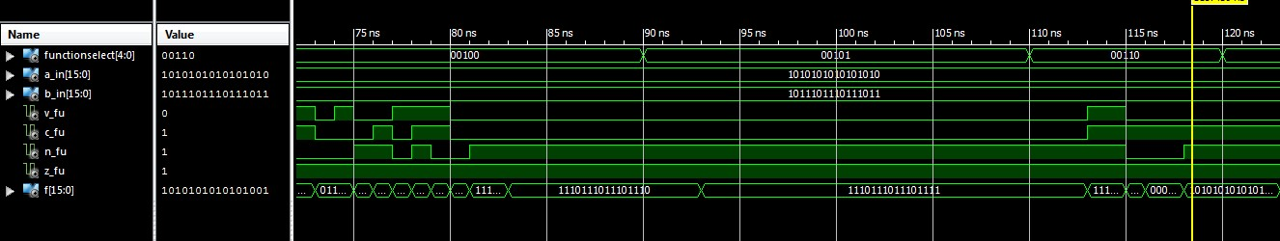

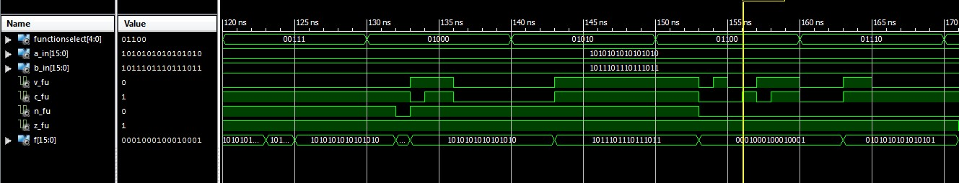

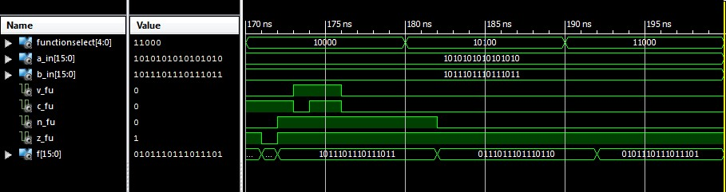

**2. VHDL Component Source Code**

a) Project 1B Top level

library IEEE;

use IEEE.STD_LOGIC_1164.ALL;

entity Proj1b is

Port(

data_in, constant_in : in STD_LOGIC_VECTOR(15 downto 0);

control_word : in STD_LOGIC_VECTOR(16 downto 0);

Clk_sig : in STD_LOGIC;

data_out, address_out : out STD_LOGIC_VECTOR(15 downto 0);

N_out, Z_out, C_out, V_out : out STD_LOGIC

);

end Proj1b;

architecture Behavioral of Proj1b is

Component reg2

Port(

des_D, add_a, add_b : in STD_LOGIC_VECTOR(2 downto 0);

Clk, load_in : in STD_LOGIC;

data : in STD_LOGIC_VECTOR(15 downto 0);

out_data_a, out_data_b : out STD_LOGIC_VECTOR(15 downto 0)

);

End Component;

Component mux

Port(

in1, in2 : in STD_LOGIC_VECTOR(15 downto 0);

s : in STD_LOGIC;

z : out STD_LOGIC_VECTOR(15 downto 0)

);

End Component;

Component function_unit

Port(

FunctionSelect : in STD_LOGIC_VECTOR(4 downto 0); -- 5 input

a_in, b_in : in STD_LOGIC_VECTOR(15 downto 0);

N_fu, Z_fu, V_fu, C_fu : out STD_LOGIC;

F : out STD_LOGIC_VECTOR(15 downto 0)

);

End Component;

signal mux_b_out, mux_d_out, reg_file_out_a, reg_file_out_b, function_unit_out : STD_LOGIC_VECTOR(15 downto 0);

begin

mux_b: mux PORT MAP(

in1 => constant_in,

in2 => reg_file_out_b,

s => control_word(7),

z => mux_b_out

);

mux_d: mux PORT MAP(

in1 => function_unit_out,

in2 => data_in,

s => control_word(1),

z => mux_d_out

);

reg1: reg2 PORT MAP(

des_D => control_word(16 downto 14),

add_a => control_word(13 downto 11),

add_b => control_word(10 downto 8),

Clk => Clk_sig,

load_in => control_word(0),

data => mux_d_out,

out_data_a => reg_file_out_a,

out_data_b => reg_file_out_b

);

data_out <= mux_b_out;

address_out <= reg_file_out_a;

function_unit1: function_unit PORT MAP(

FunctionSelect => control_word(6 downto 2),

A_in => reg_file_out_a,

B_in => mux_b_out,

N_fu => N_out,

Z_fu => Z_out,

C_fu => C_out,

V_fu => V_out,

F => function_unit_out

);

end Be havioral;

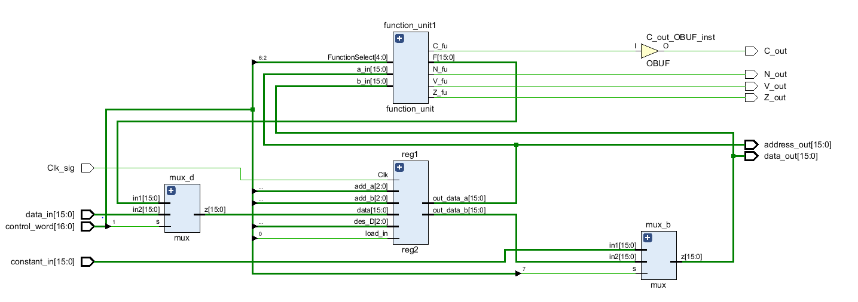

b) Register File

library IEEE;

use IEEE.STD_LOGIC_1164.ALL;

entity reg2 is

Port(

des_D, add_a, add_b : in STD_LOGIC_VECTOR(2 downto 0);

Clk, load_in : in STD_LOGIC;

data : in STD_LOGIC_VECTOR(15 downto 0);

out_data_a, out_data_b : out STD_LOGIC_VECTOR(15 downto 0)

);

end reg2;

architecture Behavioral of reg2 is

Component reg16

Port(

D : in STD_LOGIC_VECTOR(15 downto 0);

load1, load2, Clk : in STD_LOGIC;

Q : out STD_LOGIC_VECTOR(15 downto 0)

);

end Component;

Component decoder

Port(

A1, A2, A3 : in STD_LOGIC;

D1, D2, D3, D4, D5, D6, D7, D8 : out STD_LOGIC

);

End Component;

Component mux

Port(

in1, in2 : STD_LOGIC_VECTOR(15 downto 0);

s : STD_LOGIC;

z : out STD_LOGIC_VECTOR(15 downto 0)

);

End Component;

Component multiplexer

Port(

in1, in2, in3, in4, in5, in6, in7, in8 : in STD_LOGIC_VECTOR(15 downto 0);

s1, s2, s3 : in STD_LOGIC;

z : out STD_LOGIC_VECTOR(15 downto 0)

);

End Component;

signal load_r1, load_r2, load_r3, load_r4, load_r5, load_r6, load_r7, load_r8 : STD_LOGIC;

signal r1_q, r2_q, r3_q, r4_q, r5_q, r6_q, r7_q, r8_q, data_src_mux_out, src_reg, out_sig_a, out_sig_b : STD_LOGIC_VECTOR(15 downto 0);

begin

Reg1: reg16 PORT MAP(

D => data,

load1 => load_r1,

load2 => load_in,

Clk => Clk,

Q => r1_q

);

Reg2: reg16 PORT MAP(

D => data,

load1 => load_r2,

load2 => load_in,

Clk => Clk,

Q => r2_q

);

Reg3: reg16 PORT MAP(

D => data,

load1 => load_r3,

load2 => load_in,

Clk => Clk,

Q => r3_q

);

Reg4: reg16 PORT MAP(

D => data,

load1 => load_r4,

load2 => load_in,

Clk => Clk,

Q => r4_q

);

Reg5: reg16 PORT MAP(

D => data,

load1 => load_r5,

load2 => load_in,

Clk => Clk,

Q => r5_q

);

Reg6: reg16 PORT MAP(

D => data,

load1 => load_r6,

load2 => load_in,

Clk => Clk,

Q => r6_q

);

Reg7: reg16 PORT MAP(

D => data,

load1 => load_r7,

load2 => load_in,

Clk => Clk,

Q => r7_q

);

Reg8: reg16 PORT MAP(

D => data,

load1 => load_r8,

load2 => load_in,

Clk => Clk,

Q => r8_q

);

des_decoder_3_8: decoder PORT MAP(

A1 => des_D(0),

A2 => des_D(1),

A3 => des_D(2),

D1 => load_r1,

D2 => load_r2,

D3 => load_r3,

D4 => load_r4,

D5 => load_r5,

D6 => load_r6,

D7 => load_r7,

D8 => load_r8

);

A_8_1_mux: multiplexer PORT MAP(

in1 => r1_q,

in2 => r2_q,

in3 => r3_q,

in4 => r4_q,

in5 => r5_q,

in6 => r6_q,

in7 => r7_q,

in8 => r8_q,

s1 => add_a(0),

s2 => add_a(1),

s3 => add_a(2),

z => out_sig_a

);

B_8_1_mux: multiplexer PORT MAP(

in1 => r1_q,

in2 => r2_q,

in3 => r3_q,

in4 => r4_q,

in5 => r5_q,

in6 => r6_q,

in7 => r7_q,

in8 => r8_q,

s1 => add_b(0),

s2 => add_b(1),

s3 => add_b(2),

z => out_sig_b

);

out_data_a <= out_sig_a;

out_data_b <= out_sig_b;

end Behavioral;

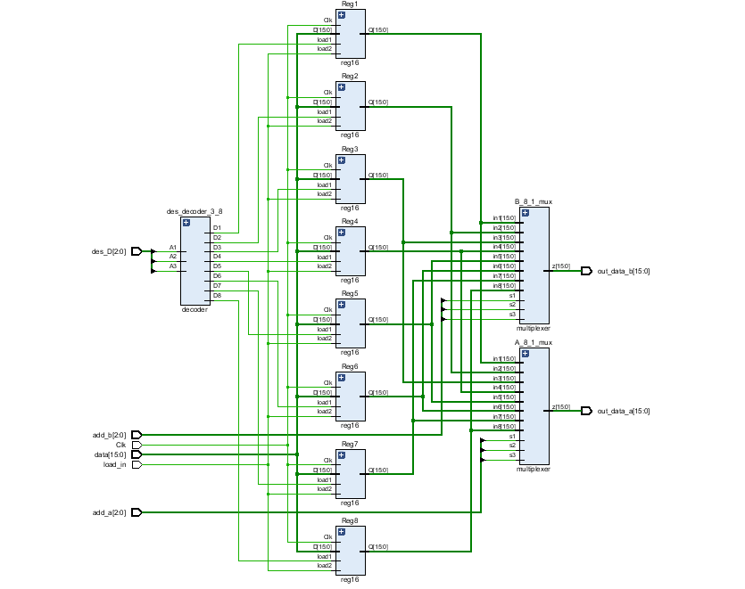

c) ALU Unit

library IEEE;

use IEEE.STD_LOGIC_1164.ALL;

entity alu_unit is

Port(

a_in, b_in : in STD_LOGIC_VECTOR(15 downto 0);

G_select : in STD_LOGIC_VECTOR(3 downto 0);

V, C : out STD_LOGIC; -- flags

G : out STD_LOGIC_VECTOR(15 downto 0)

);

end alu_unit;

architecture Behavioral of alu_unit is

Component ripple_adder

Port(

A, B : in STD_LOGIC_VECTOR(15 downto 0);

Cin : in STD_LOGIC;

Cout, V_out : out STD_LOGIC;

G_out : out STD_LOGIC_VECTOR(15 downto 0)

);

End Component;

Component bus_a_b

Port(

a_logic_in, b_logic_in : in STD_LOGIC_VECTOR(15 downto 0);

select_in : in STD_LOGIC_VECTOR(1 downto 0);

logic_output_a_b : out STD_LOGIC_VECTOR(15 downto 0)

);

End Component;

Component bus_b

Port(

B : in STD_LOGIC_VECTOR(15 downto 0);

S_in : in STD_LOGIC_VECTOR(1 downto 0);

Y_out : out STD_LOGIC_VECTOR(15 downto 0)

);

End Component;

Component mux

Port(

in1, in2 : in STD_LOGIC_VECTOR(15 downto 0);

s : in STD_LOGIC;

z : out STD_LOGIC_VECTOR(15 downto 0)

);

End Component;

signal logic_out, logic_output_a_b, ripple_out : STD_LOGIC_VECTOR(15 downto 0);

begin

r_adder: ripple_adder PORT MAP(

A => a_in,

B => b_in,

Cin => G_select(0),

Cout => C,

V_out => V,

G_out => ripple_out

);

logic_circuit_a_b: bus_a_b PORT MAP(

a_logic_in => a_in,

b_logic_in => b_in,

select_in => G_select(2 downto 1),

logic_output_a_b => logic_output_a_b

);

logic_circuit_b : bus_b PORT MAP(

B => b_in,

S_in => G_select(2 downto 1),

Y_out => logic_out

);

mux_2_16: mux PORT MAP(

in1 => ripple_out,

in2 => logic_output_a_b,

s => G_select(3),

z => G

);

end Behavioral;

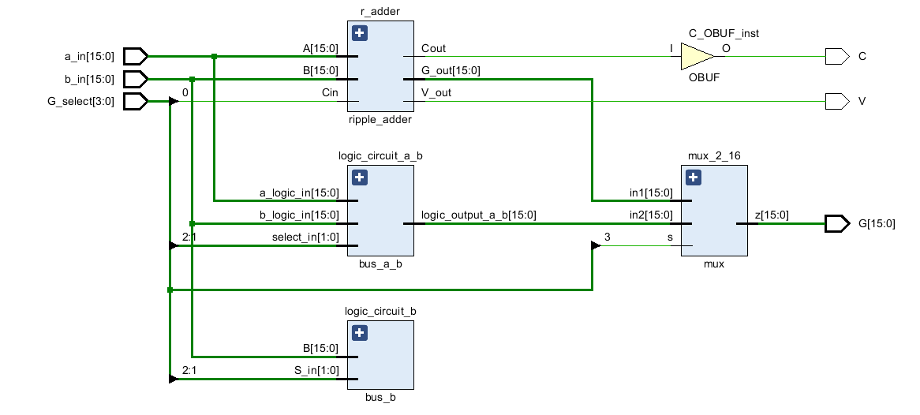

d) Decoder 3-8 Bit

library IEEE;

use ieee.std_logic_1164.all;

use ieee.std_logic_arith.all;

use ieee.std_logic_unsigned.all;

entity decoder is

port(A1, A2, A3: in std_logic;

D1, D2, D3, D4, D5, D6, D7, D8: out std_logic);

end decoder;

architecture Behavioral of decoder is

begin

D1<=((not A1) and (not A2) and (not A3)) after 10ns ;

D2<=((not A1) and (not A2) and (A3)) after 10ns ;

D3<=((not A1) and (A2) and (not A3)) after 10ns ;

D4<=((not A1) and (A2) and (A3)) after 10ns ;

D5<=((A1) and (not A2) and (not A3)) after 10ns ;

D6<=((A1) and (not A2) and (A3)) after 10ns ;

D7<=((A1) and (A2) and (not A3)) after 10ns ;

D8<=((A1) and (A2) and (A3)) after 10ns ;

end Behavioral;

e) Full Adder

library IEEE;

use IEEE.STD_LOGIC_1164.ALL;

entity full_adder is

Port(

X, Y, Cin : in STD_LOGIC;

Cout, S : out STD_LOGIC

);

end full_adder;

architecture Behavioral of full_adder is

signal S1, S2, S3 : STD_LOGIC;

begin

S1 <= (X xor Y) after 1ns;

S2 <= (Cin and S1) after 1ns;

S3 <= (X and Y) after 1ns;

S <= (S1 xor Cin) after 1ns;

Cout <= (S2 or S3) after 1ns;

end Behavioral;

f) Functional Unit

library IEEE;

use IEEE.STD_LOGIC_1164.ALL;

entity function_unit is

Port(

FunctionSelect : in STD_LOGIC_VECTOR(4 downto 0); -- 5 input

a_in, b_in : in STD_LOGIC_VECTOR(15 downto 0);

N_fu, Z_fu, V_fu, C_fu : out STD_LOGIC;

F : out STD_LOGIC_VECTOR(15 downto 0));

end function_unit;

architecture Behavioral of function_unit is

Component mux

Port(

in1, in2 : in STD_LOGIC_VECTOR(15 downto 0);

s : in STD_LOGIC; z : out STD_LOGIC_VECTOR(15 downto 0));

End Component;

Component shifter

Port(

B : in STD_LOGIC_VECTOR(15 downto 0);

S : in STD_LOGIC_VECTOR(1 downto 0);

IL, IR : in STD_LOGIC;

H : out STD_LOGIC_VECTOR(15 downto 0));

End Component;

Component alu_unit

Port(

a_in, b_in : in STD_LOGIC_VECTOR(15 downto 0);

G_select : in STD_LOGIC_VECTOR(3 downto 0);

V, C : out STD_LOGIC; -- flags

G : out STD_LOGIC_VECTOR(15 downto 0) );

End Component;

signal H_out, ALU_out, mux_out : STD_LOGIC_VECTOR(15 downto 0);

begin

shifter0: shifter PORT MAP(

B => b_in, S => FunctionSelect(3 downto 2),

IL => '0', IR => '0', H => H_out );

mux_2_16: mux PORT MAP(

in1 => ALU_out, in2 => H_out,

s => FunctionSelect(4), z => mux_out );

alu: alu_unit PORT MAP(

a_in => a_in, b_in => b_in,

G_select => FunctionSelect(3 downto 0),

V => V_fu, C => C_fu, G => ALU_out );

F <= mux_out; N_fu <= mux_out(15);

Z_fu <= (mux_out(15) or mux_out(14) or mux_out(13) or mux_out(12) or mux_out(11)

or mux_out(10) or mux_out(9) or mux_out(8) or mux_out(7) or mux_out(6)

or mux_out(5) or mux_out(4) or mux_out(3) or mux_out(2) or mux_out(1) or mux_out(0));

end Behavioral;

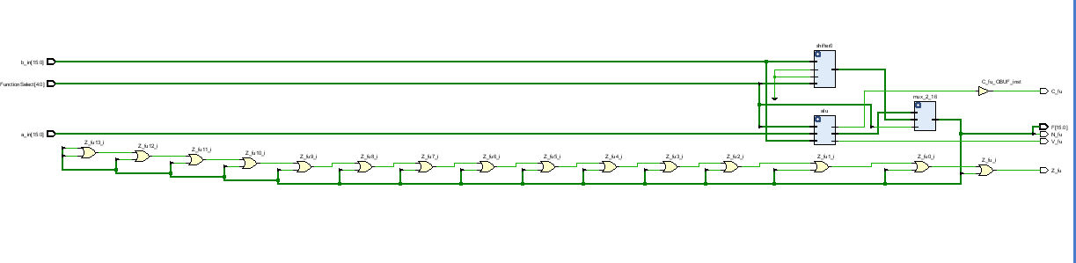

g) Logic Circuit A-B

library IEEE;

use IEEE.STD_LOGIC_1164.ALL;

entity bus_a_b is

Port(

a_logic_in, b_logic_in : in STD_LOGIC_VECTOR(15 downto 0);

select_in : in STD_LOGIC_VECTOR(1 downto 0);

logic_output_a_b : out STD_LOGIC_VECTOR(15 downto 0)

);

end bus_a_b;

architecture Behavioral of bus_a_b is

begin

logic_output_a_b <= (a_logic_in and b_logic_in) after 10ns when select_in = "00" else (a_logic_in or b_logic_in) after 10ns when select_in = "01" else

(a_logic_in xor b_logic_in) after 10ns when select_in = "10" else

(not (a_logic_in)) after 1ns;

end Behavioral;

h) Logic Circuit B

library IEEE;

use IEEE.STD_LOGIC_1164.ALL;

entity bus_b is

Port(

B : in STD_LOGIC_VECTOR(15 downto 0);

S_in : in STD_LOGIC_VECTOR(1 downto 0);

Y_out : out STD_LOGIC_VECTOR(15 downto 0)

);

end bus_b;

architecture Behavioral of bus_b is

Component mux_2_1

Port(

B_i, S1, S2 : in STD_LOGIC;

Y_i : out STD_LOGIC

);

End Component;

begin

mux1: mux_2_1 PORT MAP(

B_i => B(0),

S1 => S_in(0),

S2 => S_in(1),

Y_i => Y_out(0)

);

mux2: mux_2_1 PORT MAP(

B_i => B(1),

S1 => S_in(0),

S2 => S_in(1),

Y_i => Y_out(1)

);

mux3: mux_2_1 PORT MAP(

B_i => B(2),

S1 => S_in(0),

S2 => S_in(1),

Y_i => Y_out(2)

);

mux4: mux_2_1 PORT MAP(

B_i => B(3),

S1 => S_in(0),

S2 => S_in(1),

Y_i => Y_out(3)

);

mux5: mux_2_1 PORT MAP(

B_i => B(4),

S1 => S_in(0),

S2 => S_in(1),

Y_i => Y_out(4)

);

mux6: mux_2_1 PORT MAP(

B_i => B(5),

S1 => S_in(0),

S2 => S_in(1),

Y_i => Y_out(5)

);

mux7: mux_2_1 PORT MAP(

B_i => B(6),

S1 => S_in(0),

S2 => S_in(1),

Y_i => Y_out(6)

);

mux8: mux_2_1 PORT MAP(

B_i => B(7),

S1 => S_in(0),

S2 => S_in(1),

Y_i => Y_out(7)

);

mux9: mux_2_1 PORT MAP(

B_i => B(8),

S1 => S_in(0),

S2 => S_in(1),

Y_i => Y_out(8)

);

mux10: mux_2_1 PORT MAP(

B_i => B(9),

S1 => S_in(0),

S2 => S_in(1),

Y_i => Y_out(9)

);

mux11: mux_2_1 PORT MAP(

B_i => B(10),

S1 => S_in(0),

S2 => S_in(1),

Y_i => Y_out(10)

);

end Behavioral;

i) Mux 2-1 Bit

library IEEE;

use IEEE.STD_LOGIC_1164.ALL;

entity mux_2_1 is

Port(

B_i, S1, S2 : in STD_LOGIC;

Y_i : out STD_LOGIC );

end mux_2_1;

architecture Behavioral of mux_2_1 is

begin

Y_i <= S1 after 1ns when B_i = '1' else

S2 after 1ns when B_i = '0' else

'0' after 1ns;

end Behavioral;

j) Mux 2-16 Bit

library IEEE;

use IEEE.STD_LOGIC_1164.ALL;

entity mux is

Port(

s : in STD_LOGIC;

in1, in2 : in STD_LOGIC_VECTOR(15 downto 0);

z : out STD_LOGIC_VECTOR(15 downto 0) );

end mux;

architecture Behavioral of mux is

begin

z <= in1 after 1ns when s = '0' else

in2 after 1ns when s = '1' else

x"0000" after 1ns;

end Behavioral;

k) Mux 3-1 Bit

library IEEE;

use IEEE.STD_LOGIC_1164.ALL;

entity mux_3_1 is

Port(

in1, in2, in3 : in STD_LOGIC; s1, s2 : in STD_LOGIC;

z : out STD_LOGIC );

end mux_3_1;

architecture Behavioral of mux_3_1 is

begin

z <= in1 after 1ns when s1 = '0' and s2 = '0' else

in2 after 1ns when s1 = '0' and s2 = '1' else

in3 after 1ns when s1 = '1' and s2 = '0' else

'0' after 1ns;

end Behavioral;

l) Mux 8-16 Bit

library IEEE;

use IEEE.STD_LOGIC_1164.ALL;

entity multiplexer is

Port ( s1, s2, s3 : in STD_LOGIC;

in1, in2, in3, in4, in5, in6, in7, in8 : in STD_LOGIC_VECTOR (15 downto 0);

z : out STD_LOGIC_VECTOR (15 downto 0));

end multiplexer;

architecture Behavioral of multiplexer is

begin

z <= in1 after 1ns when s1 = '0' and s2 = '0' and s3 = '0' else

in2 after 1ns when s1 = '0' and s2 = '0' and s3 = '1' else

in3 after 1ns when s1 = '0' and s2 = '1' and s3 = '0' else

in4 after 1ns when s1 = '0' and s2 = '1' and s3 = '1' else

in5 after 1ns when s1 = '1' and s2 = '0' and s3 = '0' else

in6 after 1ns when s1 = '1' and s2 = '0' and s3 = '1' else

in7 after 1ns when s1 = '1' and s2 = '1' and s3 = '0' else

in8 after 1ns when s1 = '1' and s2 = '1' and s3 = '1' else

x"0000" after 10ns;

end Behavioral;

m) Register

library IEEE;

use IEEE.STD_LOGIC_1164.ALL;

entity reg16 is

Port(

D : in STD_LOGIC_VECTOR(15 downto 0);

load1, load2, Clk : in STD_LOGIC;

Q : out STD_LOGIC_VECTOR(15 downto 0)

);

end reg16;

architecture Behavioral of reg16 is

begin

process (Clk)

begin

if(rising_edge(Clk)) then

if((load1 = '1') and (load2 = '1')) then

Q <= D after 5ns;

end if;

end if;

end process;

end Behavioral;

n) Ripple Adder

library IEEE;

use IEEE.STD_LOGIC_1164.ALL;

entity shifter is

Port(

B : in STD_LOGIC_VECTOR(15 downto 0);

S : in STD_LOGIC_VECTOR(1 downto 0);

IL, IR : in STD_LOGIC;

H : out STD_LOGIC_VECTOR(15 downto 0) );

end shifter;

architecture Behavioral of shifter is

Component mux_3_1

Port(

in1, in2, in3, s1, s2 : in STD_LOGIC;

z : out STD_LOGIC );

End Component;

begin

mux1: mux_3_1 PORT MAP(

in1 => B(0),

in2 => B(1),

in3 => IL,

s1 => S(0),

s2 => S(1),

z => H(0)

);

mux2: mux_3_1 PORT MAP(

in1 => B(1),

in2 => B(2),

in3 => B(0),

s1 => S(0),

s2 => S(1),

z => H(1) );

mux3: mux_3_1 PORT MAP(

in1 => B(2),

in2 => B(3),

in3 => B(1),

s1 => S(0),

s2 => S(1),

z => H(2) );

mux4: mux_3_1 PORT MAP(

in1 => B(3),

in2 => B(4),

in3 => B(2),

s1 => S(0),

s2 => S(1),

z => H(3) );

mux5: mux_3_1 PORT MAP(

in1 => B(4),

in2 => B(5),

in3 => B(3),

s1 => S(0),

s2 => S(1),

z => H(4) );

mux6: mux_3_1 PORT MAP(

in1 => B(5),

in2 => B(6),

in3 => B(4),

s1 => S(0),

s2 => S(1),

z => H(5) );

mux7: mux_3_1 PORT MAP(

in1 => B(6),

in2 => B(7),

in3 => B(5),

s1 => S(0),

s2 => S(1),

z => H(6) );

mux8: mux_3_1 PORT MAP(

in1 => B(7),

in2 => B(8),

in3 => B(6),

s1 => S(0),

s2 => S(1),

z => H(7) );

mux9: mux_3_1 PORT MAP(

in1 => B(8),

in2 => B(9),

in3 => B(7),

s1 => S(0),

s2 => S(1),

z => H(8) );

mux10: mux_3_1 PORT MAP(

in1 => B(9),

in2 => B(10),

in3 => B(8),

s1 => S(0),

s2 => S(1),

z => H(9) );

mux11: mux_3_1 PORT MAP(

in1 => B(10),

in2 => B(11),

in3 => B(9),

s1 => S(0),

s2 => S(1),

z => H(10) );

mux12: mux_3_1 PORT MAP(

in1 => B(11),

in2 => B(12),

in3 => B(10),

s1 => S(0),

s2 => S(1),

z => H(11) );

mux13: mux_3_1 PORT MAP(

in1 => B(12),

in2 => B(13),

in3 => B(11),

s1 => S(0),

s2 => S(1),

z => H(12) );

mux14: mux_3_1 PORT MAP(

in1 => B(13),

in2 => B(14),

in3 => B(12),

s1 => S(0),

s2 => S(1),

z => H(13));

mux15: mux_3_1 PORT MAP(

in1 => B(14),

in2 => B(15),

in3 => B(13),

s1 => S(0),

s2 => S(1),

z => H(14) );

mux16: mux_3_1 PORT MAP(

in1 => B(15),

in2 => IR,

in3 => B(14),

s1 => S(0),

s2 => S(1),

z => H(15) );

end Behavioral;

o) Shifter

library IEEE;

use IEEE.STD_LOGIC_1164.ALL;

entity shifter is

Port(

B : in STD_LOGIC_VECTOR(15 downto 0);

S : in STD_LOGIC_VECTOR(1 downto 0);

IL, IR : in STD_LOGIC;

H : out STD_LOGIC_VECTOR(15 downto 0) );

end shifter;

architecture Behavioral of shifter is

Component mux_3_1

Port(

in1, in2, in3, s1, s2 : in STD_LOGIC;

z : out STD_LOGIC );

End Component;

begin

mux1: mux_3_1 PORT MAP(

in1 => B(0),

in2 => B(1),

in3 => IL,

s1 => S(0),

s2 => S(1),

z => H(0) );

mux2: mux_3_1 PORT MAP(

in1 => B(1),

in2 => B(2),

in3 => B(0),

s1 => S(0),

s2 => S(1),

z => H(1)

);

mux3: mux_3_1 PORT MAP(

in1 => B(2),

in2 => B(3),

in3 => B(1),

s1 => S(0),

s2 => S(1),

z => H(2)

);

mux4: mux_3_1 PORT MAP(

in1 => B(3),

in2 => B(4),

in3 => B(2),

s1 => S(0),

s2 => S(1),

z => H(3)

);

mux5: mux_3_1 PORT MAP(

in1 => B(4),

in2 => B(5),

in3 => B(3),

s1 => S(0),

s2 => S(1),

z => H(4)

);

mux6: mux_3_1 PORT MAP(

in1 => B(5),

in2 => B(6),

in3 => B(4),

s1 => S(0),

s2 => S(1),

z => H(5)

);

mux7: mux_3_1 PORT MAP(

in1 => B(6),

in2 => B(7),

in3 => B(5),

s1 => S(0),

s2 => S(1),

z => H(6)

);

mux8: mux_3_1 PORT MAP(

in1 => B(7),

in2 => B(8),

in3 => B(6),

s1 => S(0),

s2 => S(1),

z => H(7)

);

mux9: mux_3_1 PORT MAP(

in1 => B(8),

in2 => B(9),

in3 => B(7),

s1 => S(0),

s2 => S(1),

z => H(8)

);

mux10: mux_3_1 PORT MAP(

in1 => B(9),

in2 => B(10),

in3 => B(8),

s1 => S(0),

s2 => S(1),

z => H(9)

);

mux11: mux_3_1 PORT MAP(

in1 => B(10),

in2 => B(11),

in3 => B(9),

s1 => S(0),

s2 => S(1),

z => H(10)

);

mux12: mux_3_1 PORT MAP(

in1 => B(11),

in2 => B(12),

in3 => B(10),

s1 => S(0),

s2 => S(1),

z => H(11)

);

mux13: mux_3_1 PORT MAP(

in1 => B(12),

in2 => B(13),

in3 => B(11),

s1 => S(0),

s2 => S(1),

z => H(12)

);

mux14: mux_3_1 PORT MAP(

in1 => B(13),

in2 => B(14),

in3 => B(12),

s1 => S(0),

s2 => S(1),

z => H(13)

);

mux15: mux_3_1 PORT MAP(

in1 => B(14),

in2 => B(15),

in3 => B(13),

s1 => S(0),

s2 => S(1),

z => H(14)

);

mux16: mux_3_1 PORT MAP(

in1 => B(15),

in2 => IR,

in3 => B(14),

s1 => S(0),

s2 => S(1),

z => H(15)

);

end Behavioral;

**3. Component Test Benches**

a) Project 1B Top Level

LIBRARY ieee;

USE ieee.std_logic_1164.ALL;

ENTITY Proj_1b_TB IS

END Proj_1b_TB;

ARCHITECTURE behavior OF Proj_1b_TB IS

COMPONENT Proj1b

PORT(

data_in : IN std_logic_vector(15 downto 0);

constant_in : IN std_logic_vector(15 downto 0);

control_word : IN std_logic_vector(16 downto 0);

Clk_sig : IN std_logic;

data_out : OUT std_logic_vector(15 downto 0);

address_out : OUT std_logic_vector(15 downto 0);

N_out : OUT std_logic;

Z_out : OUT std_logic;

C_out : OUT std_logic;

V_out : OUT std_logic

);

END COMPONENT;

signal data_in : std_logic_vector(15 downto 0) := (others => '0');

signal constant_in : std_logic_vector(15 downto 0) := (others => '0');

signal control_word : std_logic_vector(16 downto 0) := (others => '0');

signal Clk_sig : std_logic := '0';

signal data_out : std_logic_vector(15 downto 0);

signal address_out : std_logic_vector(15 downto 0);

signal N_out : std_logic;

signal Z_out : std_logic;

signal C_out : std_logic;

signal V_out : std_logic;

constant Clk_sig_period : time := 10 ns;

BEGIN

uut: Proj1b PORT MAP (

data_in => data_in, constant_in => constant_in,

control_word => control_word, Clk_sig => Clk_sig,

data_out => data_out, address_out => address_out,

N_out => N_out, Z_out => Z_out, C_out => C_out,

V_out => V_out );

Clk_sig_process :process

begin

Clk_sig <= '0';

wait for Clk_sig_period/2;

Clk_sig <= '1';

wait for Clk_sig_period/2;

end process;

stim_proc: process

begin

data_in <= x"FFFF";

constant_in <= x"0000";

control_word <= "00000000100000011"; wait for 40ns;

data_in <= x"AAAA";

control_word <= "00100000100000011"; wait for 40ns;

control_word <= "01000000100110001"; wait for 40ns;

control_word <= "01001001001000000";

wait;

end process;

END;

b) Register File

LIBRARY ieee;

USE ieee.std_logic_1164.ALL;

ENTITY reg2_TB IS

END reg2_TB;

ARCHITECTURE behavior OF reg2_TB IS

COMPONENT reg2

PORT(

des_D : IN std_logic_vector(2 downto 0);

add_a : IN std_logic_vector(2 downto 0);

add_b : IN std_logic_vector(2 downto 0);

Clk : IN std_logic;

load_in : IN std_logic;

data : IN std_logic_vector(15 downto 0);

out_data_a : OUT std_logic_vector(15 downto 0);

out_data_b : OUT std_logic_vector(15 downto 0)

);

END COMPONENT;

signal des_D : std_logic_vector(2 downto 0) := (others => '0');

signal add_a : std_logic_vector(2 downto 0) := (others => '0');

signal add_b : std_logic_vector(2 downto 0) := (others => '0');

signal Clk : std_logic := '0';

signal load_in : std_logic := '0';

signal data : std_logic_vector(15 downto 0) := (others => '0');

signal out_data_a : std_logic_vector(15 downto 0);

signal out_data_b : std_logic_vector(15 downto 0);

constant Clk_period : time := 10ns;

BEGIN

uut: reg2 PORT MAP (

des_D => des_D,

add_a => add_a,

add_b => add_b,

Clk => Clk,

load_in => load_in,

data => data,

out_data_a => out_data_a,

out_data_b => out_data_b

);

Clk_process :process

begin

Clk <= '0';

wait for Clk_period/2;

Clk <= '1';

wait for Clk_period/2;

end process;

stim_proc: process

begin

wait;

end process;

END;

c) ALU Unit

LIBRARY ieee;

USE ieee.std_logic_1164.ALL;

ENTITY ALU_TB IS

END ALU_TB;

ARCHITECTURE behavior OF ALU_TB IS

COMPONENT alu_unit

PORT(

a_in : IN std_logic_vector(15 downto 0);

b_in : IN std_logic_vector(15 downto 0);

G_select : IN std_logic_vector(3 downto 0);

V : OUT std_logic;

C : OUT std_logic;

G : OUT std_logic_vector(15 downto 0)

);

END COMPONENT;

signal a_in : std_logic_vector(15 downto 0) := (others => '0');

signal b_in : std_logic_vector(15 downto 0) := (others => '0');

signal G_select : std_logic_vector(3 downto 0) := (others => '0');

signal V : std_logic;

signal C : std_logic;

signal G : std_logic_vector(15 downto 0);

BEGIN

uut: alu_unit PORT MAP (

a_in => a_in,

b_in => b_in,

G_select => G_select,

V => V,

C => C,

G => G

);

stim_proc: process

begin

a_in <= x"FFAA";

b_in <= x"000F";

G_select <= "0000";

wait for 100ns;

G_select <= "0001";

wait for 100ns;

G_select <= "0010";

wait for 100ns;

G_select <= "0010";

wait for 100ns;

G_select <= "0011";

wait for 100ns;

G_select <= "0100";

wait for 100ns;

G_select <= "0101";

wait for 100ns;

G_select <= "0110";

wait for 100ns;

G_select <= "0111";

wait;

end process;

END;

d) Decoder 3-8 Bit

library IEEE;

use IEEE.Std_logic_1164.all;

use IEEE.Numeric_Std.all;

entity decoder_tb is

end;

architecture behavior of decoder_tb is

component decoder

port(A1, A2, A3: in std_logic;

D1, D2, D3, D4, D5, D6, D7, D8: out std_logic);

end component;

signal A1, A2, A3: std_logic;

signal D1, D2, D3, D4, D5, D6, D7, D8: std_logic;

begin

uut: decoder port map ( A1 => A1,A2 => A2, A3 => A3,

D1 => D1,D2 => D2,D3 => D3,D4 => D4,D5 => D5,D6 => D6,D7 => D7,D8 => D8);

stimulus: process

begin

wait for 10ns; A1 <= '0';A2 <= '0';A3 <= '0';

wait for 10ns; A1 <= '0';A2 <= '0';A3 <= '1';

wait for 10ns; A1 <= '0';A2 <= '1';A3 <= '0';

wait for 10ns; A1 <= '0';A2 <= '1';A3 <= '1';

wait for 10ns; A1 <= '1';A2 <= '0';A3 <= '0';

wait for 10ns; A1 <= '1';A2 <= '0';A3 <= '1';

wait for 10ns; A1 <= '1';A2 <= '1';A3 <= '0';

wait for 10ns; A1 <= '1';A2 <= '1';A3 <= '1';

wait;

end process;

end;

e) Full Adder

LIBRARY ieee;

USE ieee.std_logic_1164.ALL;

ENTITY full_adder_TB IS

END full_adder_TB;

ARCHITECTURE behavior OF full_adder_TB IS

COMPONENT full_adder

PORT(

X : IN std_logic; Y : IN std_logic; Cin : IN std_logic; Cout : OUT std_logic;

S : OUT std_logic );

END COMPONENT;

signal X : std_logic := '0'; signal Y : std_logic := '0';

signal Cin : std_logic := '0'; signal Cout : std_logic; signal S : std_logic;

BEGIN

uut: full_adder PORT MAP (

X => X, Y => Y,

Cin => Cin, Cout => Cout,

S => S );

stim_proc: process

begin

wait for 15ns; X <= '1';

wait for 15ns; X <= '0'; Y <= '1';

wait for 15ns; X <= '1';

wait for 15ns; Cin <= '1';

wait for 15ns; Y <= '0';

wait for 15ns; X <= '0';

wait;

end process;

END;

f) Function Unit

LIBRARY ieee;

USE ieee.std_logic_1164.ALL;

ENTITY function_unit_tb IS

END function_unit_tb;

ARCHITECTURE behavior OF function_unit_tb IS

COMPONENT function_unit

PORT(

FunctionSelect : IN std_logic_vector(4 downto 0);

a_in : IN std_logic_vector(15 downto 0);

b_in : IN std_logic_vector(15 downto 0);

N_fu : OUT std_logic;

Z_fu : OUT std_logic;

V_fu : OUT std_logic;

C_fu : OUT std_logic;

F : OUT std_logic_vector(15 downto 0)

);

END COMPONENT;

signal FunctionSelect : std_logic_vector(4 downto 0) := (others => '0');

signal a_in : std_logic_vector(15 downto 0) := (others => '0');

signal b_in : std_logic_vector(15 downto 0) := (others => '0');

signal N_fu : std_logic;

signal Z_fu : std_logic;

signal V_fu : std_logic;

signal C_fu : std_logic;

signal F : std_logic_vector(15 downto 0);

BEGIN

uut: function_unit PORT MAP (

FunctionSelect => FunctionSelect,

a_in => a_in,

b_in => b_in,

N_fu => N_fu,

Z_fu => Z_fu,

V_fu => V_fu,

C_fu => C_fu,

F => F

);

stim_proc: process

begin

a_in <= x"AAAA"; b_in <= x"BBBB";

wait for 10ns; FunctionSelect <= "00000";

wait for 10ns; FunctionSelect <= "00001";

wait for 10ns; FunctionSelect <= "00010";

wait for 10ns; FunctionSelect <= "00011";

wait for 10ns; FunctionSelect <= "00100";

wait for 10ns; FunctionSelect <= "00101";

wait for 10ns; FunctionSelect <= "00110";

wait for 10ns; FunctionSelect <= "00111";

wait for 10ns; FunctionSelect <= "01000";

wait for 10ns; FunctionSelect <= "01010";

wait for 10ns; FunctionSelect <= "01100";

wait for 10ns; FunctionSelect <= "01110";

wait for 10ns; FunctionSelect <= "10000";

wait for 10ns; FunctionSelect <= "10100";

wait for 10ns; FunctionSelect <= "11000";

wait;

end process;

END;

g) Logic Circuit A-B

LIBRARY ieee;

USE ieee.std_logic_1164.ALL;

ENTITY bus_a_b_tb IS

END bus_a_b_tb;

ARCHITECTURE behavior OF bus_a_b_tb IS

COMPONENT bus_a_b

PORT(

a_logic_in : IN std_logic_vector(15 downto 0);

b_logic_in : IN std_logic_vector(15 downto 0);

select_in : IN std_logic_vector(1 downto 0);

logic_output_a_b : OUT std_logic_vector(15 downto 0) );

END COMPONENT;

signal a_logic_in : std_logic_vector(15 downto 0) := (others => '0');

signal b_logic_in : std_logic_vector(15 downto 0) := (others => '0');

signal select_in : std_logic_vector(1 downto 0) := (others => '0');

signal logic_output_a_b : std_logic_vector(15 downto 0);

BEGIN

uut: bus_a_b PORT MAP (

a_logic_in => a_logic_in, b_logic_in => b_logic_in,

select_in => select_in,

logic_output_a_b => logic_output_a_b );

stim_proc: process

begin

wait for 20ns; a_logic_in <= x"FFFF"; b_logic_in <= x"9999";select_in <= "00"; wait for 10ns; select_in <= "01"; wait for 10ns; select_in <= "10";

wait for 10ns;select_in <= "11";

wait;

end process;

END;

h) Logic Circuit B

LIBRARY ieee;

USE ieee.std_logic_1164.ALL;

ENTITY bus_b_tb IS

END bus_b_tb;

ARCHITECTURE behavior OF bus_b_tb IS

COMPONENT bus_b

PORT(

B : IN std_logic_vector(15 downto 0);

S_in : IN std_logic_vector(1 downto 0);

Y_out : OUT std_logic_vector(15 downto 0) );

END COMPONENT;

signal B : std_logic_vector(15 downto 0) := (others => '0');

signal S_in : std_logic_vector(1 downto 0) := (others => '0');

signal Y_out : std_logic_vector(15 downto 0);

BEGIN

uut: bus_b PORT MAP (

B => B,

S_in => S_in,

Y_out => Y_out );

stim_proc: process

begin

B <= x"AAAA"; S_in <= "00";

wait for 10ns; S_in <= "01";

wait for 10ns; S_in <= "10";

wait for 10ns; S_in <= "11";

wait;

end process;

END;

i) Mux 2-1 Bit

LIBRARY ieee;

USE ieee.std_logic_1164.ALL;

ENTITY mux_n_TB IS

END mux_n_TB;

ARCHITECTURE behavior OF mux_n_TB IS

COMPONENT mux_2_1

PORT(

B_i : IN std_logic;

S1 : IN std_logic;

S2 : IN std_logic;

Y_i : OUT std_logic );

END COMPONENT;

signal B_i : std_logic := '0';

signal S1 : std_logic := '0';

signal S2 : std_logic := '0';

signal Y_i : std_logic;

BEGIN

uut: mux_2_1 PORT MAP (

B_i => B_i,

S1 => S1,

S2 => S2,

Y_i => Y_i );

stim_proc: process

begin

S1 <= '1'; S2 <= '0';

wait for 5ns; B_i <= '1';

wait for 5ns; B_i <= '0';

wait;

end process;

END;

j) Mux 2-16 bit

LIBRARY ieee;

USE ieee.std_logic_1164.ALL;

ENTITY mux_tb IS

END mux_tb;

ARCHITECTURE behavior OF mux_tb IS

COMPONENT mux

PORT(

in1 : IN std_logic_vector(15 downto 0);

in2 : IN std_logic_vector(15 downto 0);

s : IN std_logic;

z : OUT std_logic_vector(15 downto 0) );

END COMPONENT;

signal in1 : std_logic_vector(15 downto 0) := (others => '0');

signal in2 : std_logic_vector(15 downto 0) := (others => '0');

signal s : std_logic := '0';

signal z : std_logic_vector(15 downto 0);

BEGIN

mux_2_16: mux PORT MAP (

in1 => in1, in2 => in2,

s => s, z => z );

stim_proc: process

begin

wait for 1ns; in1 <= x"FFFF"; in2 <= x"AAAA";

wait for 1ns; s <= '1';

wait for 1ns; s <= '0';

wait for 1ns; s <= '1';

end process;

END;

k) Mux 3-1 Bit

LIBRARY ieee;

USE ieee.std_logic_1164.ALL;

ENTITY mux_3_1_TB IS

END mux_3_1_TB;

ARCHITECTURE behavior OF mux_3_1_TB IS

COMPONENT mux_3_1

PORT(

In1 : IN std_logic; In2 : IN std_logic; In3 : IN std_logic;

S1 : IN std_logic; S2 : IN std_logic;

Z : OUT std_logic );

END COMPONENT;

signal In1 : std_logic := '0'; signal In2 : std_logic := '0'; signal In3 : std_logic := '0';

signal S1 : std_logic := '0'; signal S2 : std_logic := '0';

signal Z : std_logic;

BEGIN

uut: mux_3_1 PORT MAP (

In1 => In1, In2 => In2, In3 => In3,

S1 => S1, S2 => S2,

Z => Z );

stim_proc: process

begin

wait for 5ns; In1 <= '1'; In2 <= '0'; In3 <= '1';

wait for 5ns; S1 <= '0'; S2 <= '1';

wait for 5ns; S1 <= '1'; S2 <= '0';

wait for 5ns; S1 <= '1'; S2 <= '1';

wait;

end process;

END;

l) Mux 8-16 Bit

LIBRARY ieee;

USE ieee.std_logic_1164.ALL;

ENTITY multiplexer_tb IS

END multiplexer_tb;

ARCHITECTURE behavior OF multiplexer_tb IS

COMPONENT multiplexer

PORT(

s1: IN std_logic;

s2: IN std_logic;

s3: IN std_logic;

in1 : IN std_logic_vector(15 downto 0);

in2 : IN std_logic_vector(15 downto 0);

in3 : IN std_logic_vector(15 downto 0);

in4 : IN std_logic_vector(15 downto 0);

in5 : IN std_logic_vector(15 downto 0);

in6 : IN std_logic_vector(15 downto 0);

in7 : IN std_logic_vector(15 downto 0);

in8 : IN std_logic_vector(15 downto 0);

z : OUT std_logic_vector(15 downto 0) );

END COMPONENT;

signal s1 : std_logic := '0';

signal s2 : std_logic := '0';

signal s3 : std_logic := '0';

signal in1 : std_logic_vector(15 downto 0) := (others => '0');

signal in2 : std_logic_vector(15 downto 0) := (others => '0');

signal in3 : std_logic_vector(15 downto 0) := (others => '0');

signal in4 : std_logic_vector(15 downto 0) := (others => '0');

signal in5 : std_logic_vector(15 downto 0) := (others => '0');

signal in6 : std_logic_vector(15 downto 0) := (others => '0');

signal in7 : std_logic_vector(15 downto 0) := (others => '0');

signal in8 : std_logic_vector(15 downto 0) := (others => '0');

signal z : std_logic_vector(15 downto 0);

BEGIN

uut: multiplexer PORT MAP (

s1 => s1,s2 => s2,s3 => s3,

in1 => in1,in2 => in2,in3 => in3,in4 => in4,in5 => in5,in6 => in6,in7 => in7,in8 => in8,

z => z

);

stim_proc: process

begin

in1 <= x"FFFF";

in2 <= x"EEEE";

in3 <= x"DDDD";

in4 <= x"CCCC";

in5 <= x"BBBB";

in6 <= x"AAAA";

in7 <= x"9999";

in8 <= x"8888";

wait for 10ns; s1 <= '1';s2 <= '0';s3 <= '0';

wait for 10ns; s1 <= '0';s2 <= '1';s3 <= '0';

wait for 10ns; s1 <= '1';s2 <= '1';s3 <= '0';

wait for 10ns; s1 <= '0';s2 <= '0';s3 <= '1';

wait for 10ns; s1 <= '1';s2 <= '0';s3 <= '1';

wait for 10ns; s1 <= '0';s2 <= '1';s3 <= '1';

wait for 10ns; s1 <= '1';s2 <= '1';s3 <= '1';

end process;

END;

m) Register

LIBRARY ieee;

USE ieee.std_logic_1164.ALL;

ENTITY reg16_TB IS

END reg16_TB;

ARCHITECTURE behavior OF reg16_TB IS

COMPONENT reg16

PORT(

D : IN std_logic_vector(15 downto 0); load1 : IN std_logic; load2 : IN std_logic;

Clk : IN std_logic; Q : OUT std_logic_vector(15 downto 0) );

END COMPONENT;

signal D : std_logic_vector(15 downto 0) := (others => '0');

signal load1 : std_logic := '0'; signal load2 : std_logic := '0';

signal Clk : std_logic := '0'; signal Q : std_logic_vector(15 downto 0);

constant Clk_period : time := 10 ns;

BEGIN

uut: reg16 PORT MAP (

D => D, load1 => load1, load2 => load2, Clk => Clk, Q => Q );

Clk_process :process

begin

Clk <= '0'; wait for Clk_period/2; Clk <= '1'; wait for Clk_period/2;

end process;

stim_proc: process

begin

D <= x"FFFF"; load1 <= '1'; load2 <= '1'; wait for 20ns;D <= x"AAAA"; load1 <= '0';

wait for 10ns; load2 <= '0'; wait for 10ns; load1 <= '1';load2 <= '1';

wait;

end process;

END;

n) Ripple Adder

LIBRARY ieee;

USE ieee.std_logic_1164.ALL;

ENTITY ripple_adder_TB IS

END ripple_adder_TB;

ARCHITECTURE behavior OF ripple_adder_TB IS

COMPONENT ripple_adder

PORT(

A : IN std_logic_vector(15 downto 0);

B : IN std_logic_vector(15 downto 0);

Cin : IN std_logic; Cout : OUT std_logic;

V_out : OUT std_logic; G_out : OUT std_logic_vector(15 downto 0) );

END COMPONENT;

signal A : std_logic_vector(15 downto 0) := (others => '0');

signal B : std_logic_vector(15 downto 0) := (others => '0');

signal Cin : std_logic := '0'; signal Cout : std_logic;

signal V_out : std_logic; signal G_out : std_logic_vector(15 downto 0);

BEGIN

uut: ripple_adder PORT MAP (

A => A, B => B,

Cin => Cin, Cout => Cout,

V_out => V_out, G_out => G_out );

stim_proc: process

begin

A <= x"AAAA"; B <= x"FBAA"; Cin <= '1';

wait for 80ns; A <= x"FFFF"; B <= x"0000"; Cin <= '1';

wait;

end process;

END;

o) Shifter

LIBRARY ieee;

USE ieee.std_logic_1164.ALL;

ENTITY shifter_tb IS

END shifter_tb;

ARCHITECTURE behavior OF shifter_tb IS

COMPONENT shifter

PORT(

B : IN std_logic_vector(15 downto 0); S : IN std_logic_vector(1 downto 0);

IL : IN std_logic; IR : IN std_logic;

H : OUT std_logic_vector(15 downto 0) );

END COMPONENT;

signal B : std_logic_vector(15 downto 0) := (others => '0');

signal S : std_logic_vector(1 downto 0) := (others => '0');

signal IL : std_logic := '0'; signal IR : std_logic := '0';

signal H : std_logic_vector(15 downto 0);

BEGIN

uut: shifter PORT MAP (

B => B, S => S, IL => IL, IR => IR,

H => H );

stim_proc: process

begin

wait for 10ns; B <= x"FFFF"; S <= "00";

wait for 10ns; S <= "01";

wait for 10ns; S <= "11";

wait for 10ns; B <= H; S <= "10";

wait;

end process;

END;